Project 1: Hello World  
CS 6610-001 Spring 2019

For this assignment, using C++, I implemented a simple window in OpenGL using FreeGLUT in Visual Studio on Windows. The window was sized explicitly, changes color automatically using OpenGL calls, and exits when the ‘Esc’ key is pressed.

There are no special instructions beyond running the project and hitting ‘Esc’ when finished being amazed.

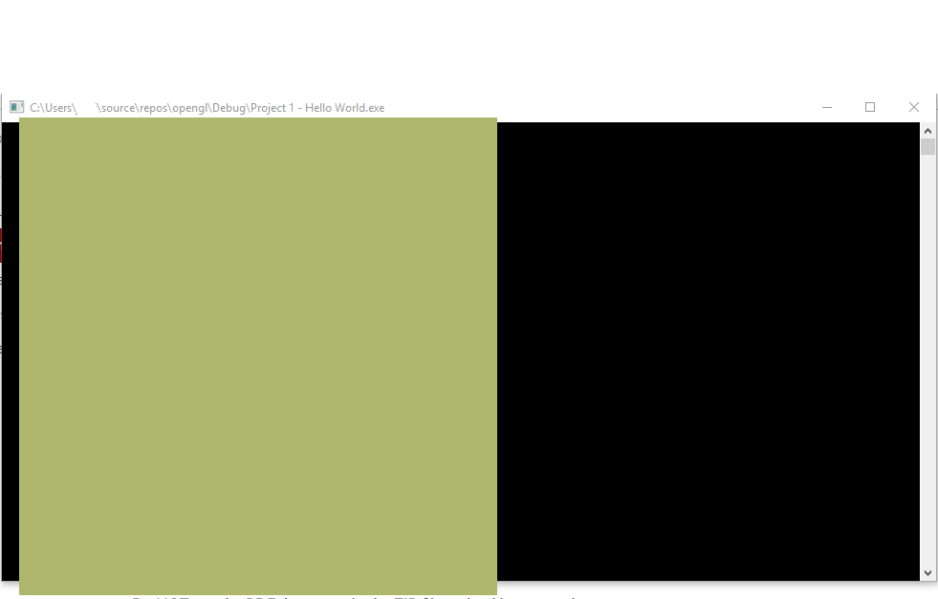

Etc.